IFT 540 (93169)

Fall 2018

Information Technology MS

Sticky Shirt Sales: Design Phase

By

Group 4

Brandon Gatto

Vincent Li

Yash Gupta

Rounak Sengupta

Kennedy Nou

ARIZONA STATE UNIVERSITY

October 2018

Table of Contents

**Introduction** **6**

Background 6

Scope of the project 6

Must Do 6

Should Do 6

Could Do 6

Won’t Do 6

Status: What have been accomplished so far 7

Objectives of this Phase 8

**User Interface Design Process** **9**

Use scenarios 9

Interface structure design 9

Interface standard design 9

Interface design prototyping 10

**Navigation Design prototype** **11**

Menus 12

Content Awareness 12

Aesthetics 12

User Experience 13

**Input Design prototype** **13**

Design Forms 13

Content Awareness 13

Aesthetics 13

User Experience 13

**Output Design prototypes** **14**

Types of Outputs 14

Content Awareness 14

Aesthetics 14

User Experience 14

Design Reports 14

**Implement the home page** **15**

**Conclusion** **16**

Share your experience in completing this phase 16

Describe the difficulties encountered and how they were overcome 16

# Introduction

## Background

There is no efficient way to see yourself in clothes that you want to order online. Currently, some online retailers allow customers to order their clothes and return them if they are unhappy with the purchase. This method is slow and inefficient. There are online stores such as Lenskart Glasses that allow you to upload a portrait of yourself in order to superimpose glasses frames onto your face. This method is a step in the right direction but only allows the superimposition of one specific kind of clothing.

There are also apps that allow you to create a type of virtual dressing room. They allow you to upload photos of clothing as well as yourself in order to superimpose the images together to create outfits. Though these apps are nice they are poorly made, only allow for a two-dimensional view and are aimed towards women exclusively.

We intend on creating a similar app but one that is far superior. It will allow the users to upload photos of themselves in order to superimpose the clothing on the photos. They will also be able to create a 3D view of themselves from these pictures. This will allow users to view themselves in the clothing before they choose to order the product. This will save time and reduce the number of returns made.

Our object is to provide instant feedback to the customer on the style on and fit of the clothing by providing them with a realistic view of them in any clothes they may be interested in purchasing. We intend on increasing customer satisfaction as well and increasing sales volume

## Scope of the project

#### Must Do

* Customer can see themselves in clothes
* Customer will have self-portrait collection
* Compare different outfits

#### Should Do

* Track customer purchase history
* 3D View

#### Could Do

* Clothing Database

#### Won’t Do

* Website design
* Design clothing

## Status: What have been accomplished so far

Within the development of this project, we have completed the following milestones:

* Established the justification for the need of our system and the project name. Described the existing solution and the base for our solution. Set up our objectives and goals. Provided a risk analysis of doing the project versus not doing the project. Established financial requirements and a timeline for the completion of the project.
* After observing and analyzing multiple documents, we also interviewed people of interest (owner of a local online brand, users of online shopping, and also the developers of our system). The interviews gave us a deeper understanding of the needs and requirements of our system. We also came up with the functional and non-functional requirements of our system.
* Next, we created the logical model for our system and along with that we also composed the documentation for it. We modeled the flow of data throughout our system as well as the relationships in the data flow. Demonstrated the processes that would change or transform the data in the system. Developed use case diagrams to show the functional requirements of the system, a high-level activity diagram to show the process a user will go through in order to use our system, as well as a sequence diagram to demonstrate how the user and web app will interact.
* We then created a representational model of the system. Developed an entity table that included entity types, attributes, attribute types, key attributes, and data types. We also created a relationship table that included relationships, attributes, participating entity types, and cardinalities. Developed a conceptual diagram as well as a complete UML class diagram.
* We have also created a representational model of our system, normalized out data in order to optimize our database for storage efficiency, and designed a physical database. In order to accomplish this, we used the 7-step algorithm to perform the ER-to-Relational Mapping, used 1-3NF to optimize for storage efficiency, and design physical data tables including: designing fields, choosing data types, controlling data integrity, etc

## 

## Objectives of this Phase

In this phase we will be defining how the system will interact with external entities such as the way system interfaces exchange information with other systems and user interface design defines the way in which the users will interact with the system. We will also explore the nature of the inputs and outputs that the system accepts and produces. We will create a UI that includes 3 fundamental parts: navigation mechanism, input mechanism, and the output mechanism

The key objective of this phase are to design and implement a user interface prototype that meets the 6 design principles for UI design and to design and implement the forms and reports.

# User Interface Design Process

## Use scenarios

* + Use case name: Login/Create Account
  + Actor: Clothing Shopper
  + Normal Course:
    - System displays default home page
    - For new user
      * Enters his name, email, phone and address
      * Creates new account
    - For old user
      * Enter his login credentials
      * Logs into his account
  + Use case name: Upload picture
  + Actor: Clothing Shopper
  + Normal Course:
    - System displays default home page
    - Clothes shopper logs into account if available (Login/Signup use case)
    - Clothes shopper chooses my account -> upload picture
    - Clothes shopper chooses from browses pictures on the device
    - Clothes shopper selects picture
    - System displays preview of the picture
    - Clothes shopper clicks upload picture

* + Use case name: Browse and select clothes
  + Actor: Clothing Shopper
  + Normal Course:
    - System displays default home page
    - Clothes shopper logs into account if available (Login/Signup use case)
    - Clothes shopper browses selection
    - Clothes shopper searches for apparel
    - Clothes shopper selects apparel adds it to the cart
    - System shows the apparel in the cart
  + Use case name: Buy/Checkout
  + Actor: Clothing Shopper
  + Normal Course:
    - Clothes shopper selects the cart
    - Clothes shopper reviews the items in the cart
    - Clothes shopper selects proceed to checkout
    - Clothes shopper enter his card details and selects buy
    - System receives the order and adds it to the database
    - System send confirmation notice to the clothes shopper

## Interface structure design

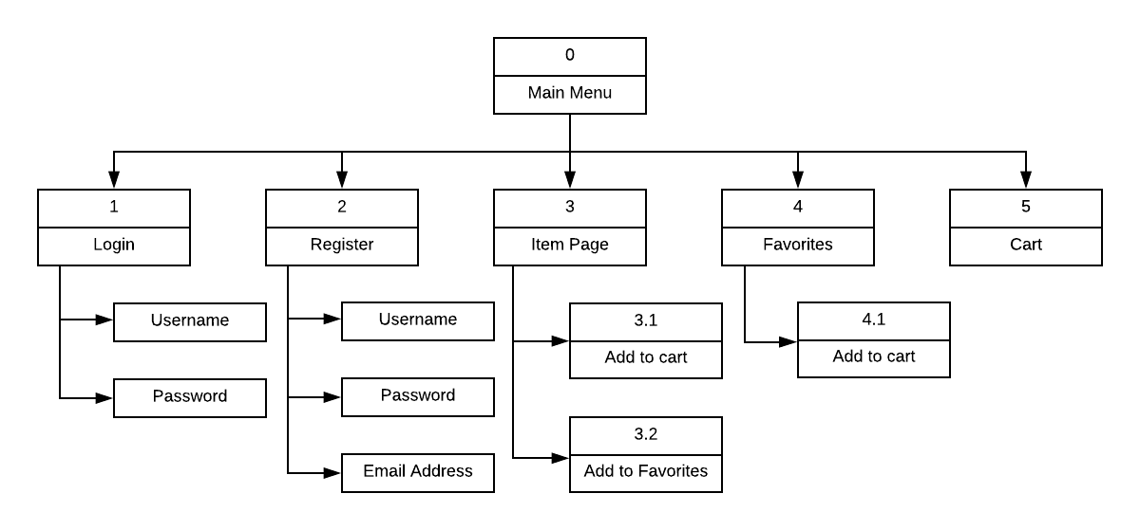

## Interface standard design

* + Interface metaphor
    - Shopping Cart



* + Interface objects
    - Customer
    - Sticky Shirt account
    - Collection
    - Cart
  + Interface actions
    - Login/Logout
    - Create Account
    - Buy
    - Favorites

## Interface design prototyping

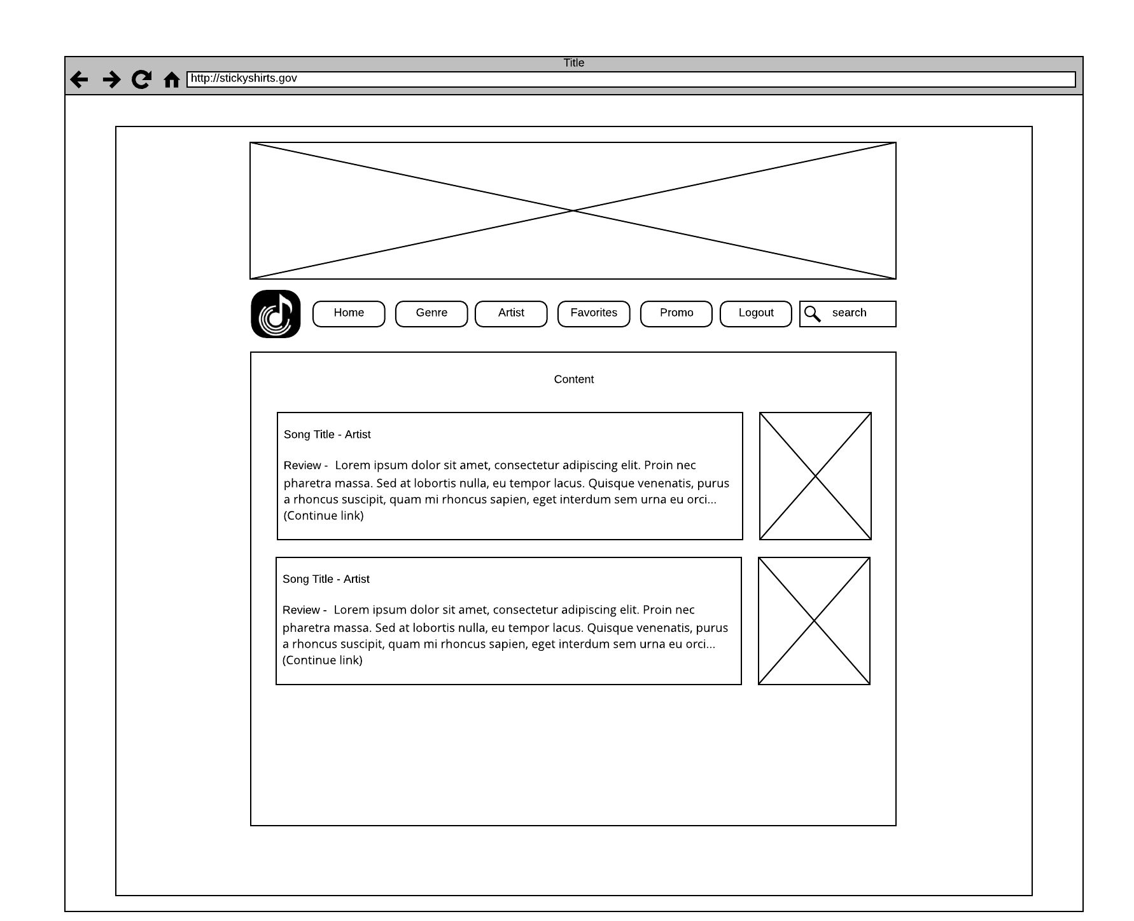

# Navigation Design prototype

### Menus

#### Content Awareness

Creating a menu that was intuitive for users to navigate our website was modeling other tested clothing brand websites. Taking cues from H&M or GAP because this part of the design has been tested by multiple other vendors over and over. We took the simple mock up that was created in the wireframe diagram and created it using html and css as a prototype. This initial phase of design is done to assure that the content presented allows users to navigate through the website in a clear and concise way without leaving the customer or user lost. 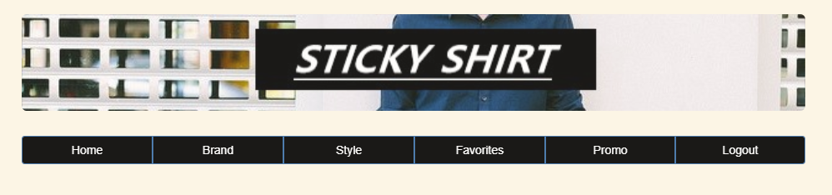

#### Aesthetics

The color scheme we choose allows clothing colors to truly pop out at the user. The slightly warm toned background allows the user to visually see white and black as individual colors rather than the traditional all white background.

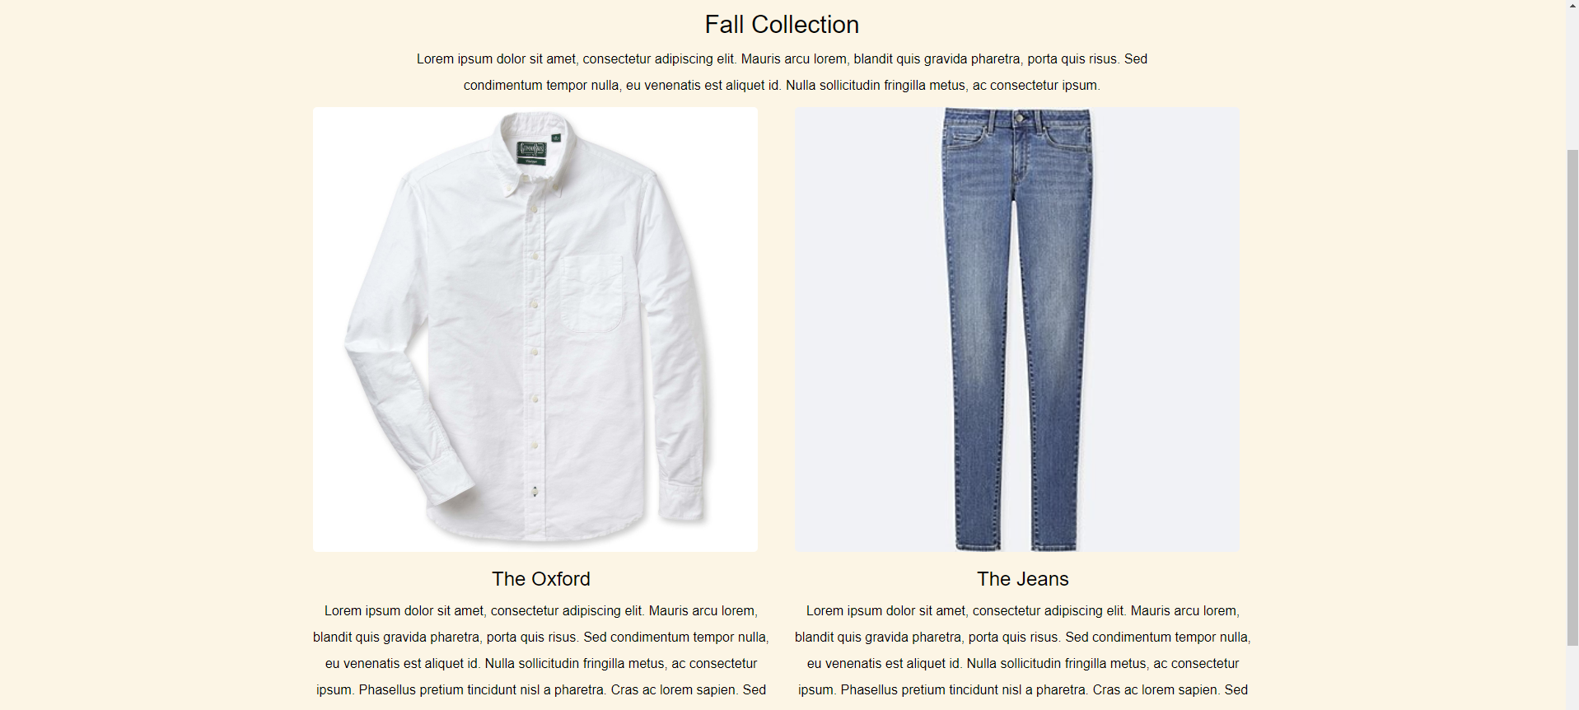

The appropriate amount of white space was considered to allow for different screen sizes while allowing maximum attention to a couple items presented at a time.

#### User Experience

The front page of our website is an easily accessible page with clearly marked areas for our promotional material with spaced out room to allow users to view only the important up to date material. The Title explains the current promotion and then a couple pictures in a rotating carousel to highlight alternate colors and styles. Below the picture has a short description of the product.

# Input Design prototype

### Design Forms

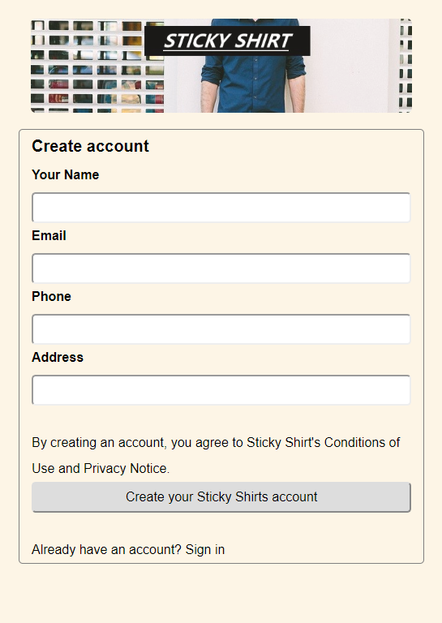

#### Content Awareness

Creating a form that covers all the requirements for us to store the basic requirements of customers to satisfy their shopping needs. Taking cues from Amazon or eBay because this part of the design has been tested by these vendors over and over. We took the simple mockup that was created in the wireframe diagram and created it using HTML and CSS as a prototype. This initial phase of design is done to assure that the content presented allows users to navigate through the website in a clear and concise way without leaving the customer or user lost.

#### Aesthetics

Maintaining the choice that we had selected earlier, we chose a color scheme that allows clothing colors to truly pop out at the user. The slightly warm toned background allows the user to visually see white and black as individual colors rather than the traditional all white background.

#### User Experience

The registration page of our website is an easily accessible page with clearly mentioned input fields and the texts related to them.

# Implement the home page

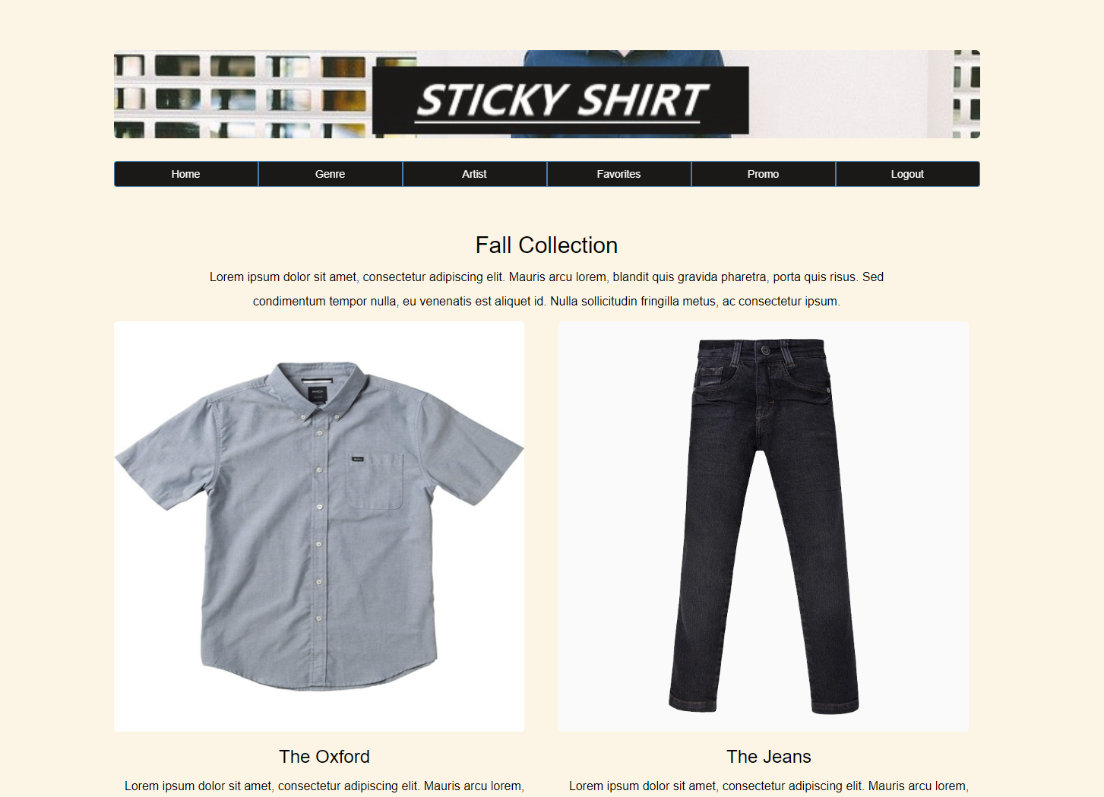

# Conclusion

### Share your experience in completing this phase

During the design phase of the software development cycle, we learned how to make a simple yet powerful user interface. We learned about 6 principles of good UI. We listed the use case scenarios and interface standard design. Using these a prototype of our website was created using HTML and CSS, keeping in mind the 6 principles.

### Describe the difficulties encountered and how they were overcome

One of the difficulties that we encountered was exploring the necessities which customers and users might need to enhance their shopping experience. There are many competitors that we can use as models which we eventually resorted to because they are tested examples of successful website but when we tried to figure out the most user focused design it was truly an art rather than a science. Between choosing color and picture placement to the menu order. Designing a front page that is effective and user friendly can be an overlooked process. It was helpful referring back to the design principles or content awareness, user experience and aesthetics when we were stuck.